Learning Diary Instructions
The Learning Diary is a useful tool to reflect your learning and to make decisions for improvement. We suggest a certain structure for the reflection of your ideas and feelings to make the process easier. On the right hand side we left some empty spaces for your drawings. You can make space for drawing by simple adding lines in any box too. Feel free not only to write, but also to draw a scheme or picture. It is especially important for visual learners. Don’t worry about the quality of drawings. It doesn’t matter. Drawing can help to arrange and express your ideas ad feelings. It can help you to write.

If you really want to improve your learning, you should write your diary every day at least for three weeks. This will help you to establish the habit of reflection. Later you can do it once or twice a week. Of course it will take some time and effort, especially in the beginning. But please, be persistent and push yourself to do that. It is a very powerful tool if used properly.

You don’t need to write long essays. It should be a very short reflection in several sentences.

Please look at the example:

Learning Diary Example

Today I have learned:  Not a „story“ about what we were doing, just what you have learned:  I learned how to count the area of the triangle.  I understood the usefulness of knowing the formula for my everyday life. | 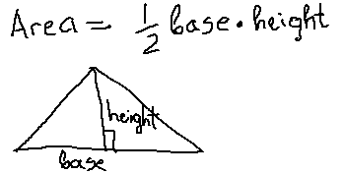
My thinking and feeling about this:  Describe your feelings and thoughts when you were learning.  My first thought was “Why do I need this? What I will do with that formula of area of the triangle?”  Then I recalled that I needed to tile the plot in my backyard which was of the shape of a triangle and I had the problem with finding how much tiles I need to buy. | My property and plot for tiling.
That was good:  Describe what was good with your learning.  The teacher explained the usefulness of the formula of calculating an area of the triangle showing us triangles in our environment, even in the classroom.  Teacher draw the wall of attic with the window and asked how we will find how many rolls of wallpaper we will need to wallpaper the wall. From this example we understood that without knowing how to calculate the area of the triangle it will be impossible.  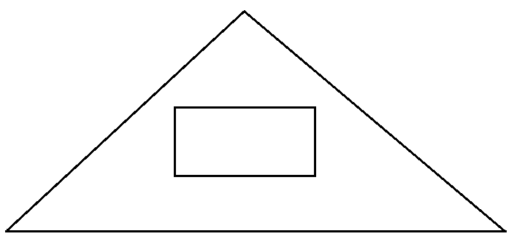 | That was not so good and I still do not understand:  The teacher gave us an assignment to calculate areas of different triangles, but for me it would be more useful if we would calculate areas of actual triangles maybe from his example of the attic wall.  I wanted to tell the story of tiling the plot in my backyard, but the teacher said that there is no time for that.  I still do not understand if this formula applies to all kind of triangles for example to this:  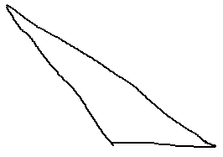
Those things helped me to learn:  Understanding how we can apply this.  Examples from reality.  Drawings.  My story of tiling the backyard plot. | Those things hindered my learning:  Abstract triangles not connected with any real situation or object.  No possibility to share ideas and experiences, cases.
I will do the following things to improve my learning:
Generally:
Try to imagine how I can apply the knowledge which I am learning.
Ask teacher or trainer, why we need to learn it and how we can apply it.
Test what I learned on real-life situation to see how it works.
Talk about my experience and my ideas with others.
Specifically:
Ask teacher if the formula applies to all kinds of triangles.

